Project Report

**Title:** Internet Speed Tester

**Submitted by:** Rohan Belsare

**Student Roll No:** 06

**Student EID:** 2303111018

**Submitted to:** Mr. R. S. Khamitkar

**Department:** Electronics and Computer Engineering

**Date:____________**

# Project Overview

This a simple python project to display the Internet Speed connected to the device. It displays the download speed (in mbps) , upload speed(in mbps) and ping of the network( in ms). Tkinter Library is used for generating the graphical user interface(GUI).

# Problem Statement

# Users lack an easy-to-use tool that can measure their internet speed accurately without relying on third-party websites. The goal of this project is to develop a Python-based Internet Speed Tester with a Graphical User Interface (GUI) that allows users to quickly check their Download Speed, Upload Speed, and Ping in real-time. The application should be simple, user-friendly, and capable of selecting the best available server to provide accurate results.

# Technology Stack

* **Programming Language:** Python 3.12.8
* **IDE: Visual studio code**

# Implementation

The implementation follows a simple logic:

* **Initialize Speedtest**:  
  st = speedtest.Speedtest() creates an object to interact with speedtest.net.
* **Find Best Server**:  
  st.get_best_server() pings multiple nearby servers and selects the one with the lowest latency (best response time).
* **Measure Speeds**:
* st.download() tests download speed by downloading data from the best server.
* st.upload() tests upload speed by uploading data to the server.
* st.results.ping gives the ping time (latency) in milliseconds.
* **Display Results**:  
  The measured speeds are converted to Mbps and shown on the GUI using StringVar in a label.

# Code Snippet

import speedtest

import tkinter as tk

from tkinter import messagebox

import threading

def test_speed():

    # Disable the button for avoiding multiple clicks

    test_button.config(state=tk.DISABLED)

    result_text.set("Testing speed... Please wait.")

    def run_speed_test():

        try:

            st = speedtest.Speedtest()

            st.get_best_server()  # select best server

            download_speed = st.download() / 1_000_000  # converts download speed into Mbps

            upload_speed = st.upload() / 1_000_000  # converts upload speed into Mbps

            ping = st.results.ping  # display ping in ms

            result_text.set(f"Download Speed: {download_speed:.2f} Mbps\n"

                             f"Upload Speed: {upload_speed:.2f} Mbps\n"

                             f"Ping: {ping:.2f} ms")

        except Exception as e:

            messagebox.showerror("Error", f"Failed to test speed.\n{e}")

        finally:

            # Re-enable the button

            test_button.config(state=tk.NORMAL)

    # Start the speed test in a new thread

    threading.Thread(target=run_speed_test).start()

# GUI using Tkinter

root = tk.Tk()

root.title("Internet Speed Tester")

root.geometry("400x300")

root.resizable(True, True)

# Title Label

tk.Label(root, text="Internet Speed Tester", font=("Arial", 16, "bold")).pack(pady=10)

# Speed test button

test_button = tk.Button(root, text="Test Speed", font=("Arial", 12), command=test_speed)

test_button.pack(pady=10)

# Result Label

result_text = tk.StringVar()

result_label = tk.Label(root, textvariable=result_text, font=("Arial", 12), justify="center")

result_label.pack(pady=20)

# Run the tkinter in loop

root.mainloop()

# Sample Test Cases

**Input: None**

**Output:**

1. **Processing:**

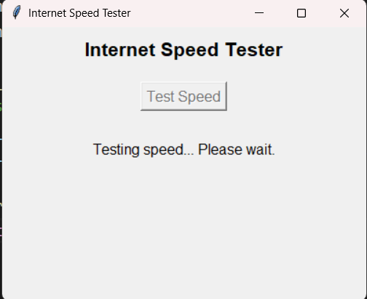

1. Result

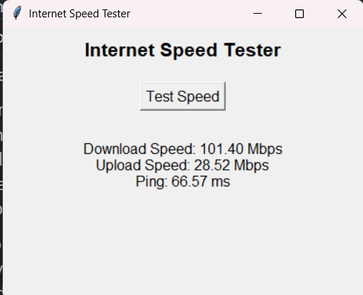

# Challenges Faced

Some challenges faced in this project included handling slow or unstable internet connections, which could cause the speed test to fail or take longer than expected. Additionally, integrating real-time results into the GUI without freezing the interface required careful exception handling and design.

# Results and Observations

The Internet Speed Tester successfully measures and displays download speed, upload speed, and ping with a simple, user-friendly GUI. It accurately selects the best server for testing, and the results closely match those from popular online speed test platforms, confirming the reliability of the application.

Project Submission

Repository Link: <https://github.com/ROAHN-B/Internet-speed-tester.git>

# Signatures

**Student Signature:**

**Guide Signature:**

**Date:**